

Ort Braude College

Software Engineering Department

**Innovative supportive social media application for Android users**

In Partial Fulfillment of the Requirements for

Final Project in Software Engineering

(Course 61771) Karmiel –June 2020

**Authors:**

Or Magogi, ID: 204381503

Naor Ohana, ID: 308554815

**Supervisor:**

Mr. Daniel Bouenos

**Contents**

1. Introduction 1
2. Theory 1
   1. Current problems 1
      1. Cyber Bullying 1
      2. Lack of caring 2
   2. Market research 2
      1. Heroes for life 2
      2. Facebook 3
      3. We heart it 3
   3. Our insights 4
   4. Our solution 4
      1. General description of the application 4
      2. Firebase as a backend service 4
      3. Android platform as a frontend 4
      4. Our application: better social experience 5
      5. Content filter algorithm 5
      6. More friendship making, volunteering and social meetings 6
      7. Ranks and points 6
      8. Ways to receive "social points" 6
      9. Redeem benefits 6
      10. *Home page and posts* 7
      11. Creating events, asking for help and volunteer 7
      12. Checking in to events and receiving the points 7
      13. Starting a new conversation and receiving points 7
      14. Cloud functions and points 7
3. Software engineering documents8
   1. Requirements 8
      1. Use-case 8
      2. Requirements table 9
   2. Design 10
      1. Class diagram 10
      2. Starting a chat conversation activity diagram 11
      3. Asking for help and volunteer:

location-based check in activity diagram 11

* + 1. Asking for help and volunteer:

manually check-in activity diagram 11

* + 1. Graphical User Interface (GUI) 12
  1. Testing 15
     1. Registration and login testing15
     2. User actions testing 15
     3. Manager actions testing 17

1. Results and conclusions 18 References 18
2. **INTRODUCTION**

The aim of this work is to provide a tool in form of Android application, that encourages people to volunteer more, receive help from others and meet new friends in a clean way. It is well known that social media applications (e.g. Facebook, Instagram, Twitter etc.) have become an integrated part of our lives.

Up until January 2019, 3.26 billion people use social media on mobile devices, with a growth of

297 million new users every year. [1]

From that number of users, we get a very high percentage of 76.67% (October 2019) of Android users. [2]

There is no doubt that social media is a wonderful platform of meeting new friends, staying up to date on worldwide issues and so on.

Unfortunately, not all the published data is appropriate. Some uses of those platforms might be as bad as

cyber harassing, blackmailing, lack of human contact and time wastage.

Moreover, caring for each other is an essential need for all of us. There are many ways people can help and care for others, but not many people are aware to them.

Thus, to try overcoming these problems, a new innovative application must take the role of changing our society.

In this article, as the second and final part of our project, we will describe in detail our suggestion to solve the problems above, including the full and updates version of our software engineering documents, and the test plan and its result.

Aiming for achieving our goals, we expect to reach millions of people.

Our application will include features that will encourage our users to make new friendships, mingle with others, meet their friends in person and leave hatred and prejudices aside. It will also push them to be politer, help others, clean the environment and make a better society.

While doing so, we hope that our users will find joy in contributing, whenever they are rewarded or not.

Our application will host contribution events (e.g. charity work, cleaning beaches etc.) and social events

(e.g. running races, barbeques etc.), as many as it will be able to.

Most importantly, our final and most eminent goal is to make a better society, for a better tomorrow.

1. **THEORY**
   1. **Current Problems**
      1. *Cyber bullying*

Cyber bullying refers to Internet bullying. It can be done by using technological devices

(e.g. computer, cellphone etc.), to bully or harass another person.

Statistics have shown that cyber bullying has become a serious problem (can be seen in Figure 1) among teenagers, But not only for them.

Cyber bullying can take many forms, such as:

* Mean and offensive messages
* Threats
* 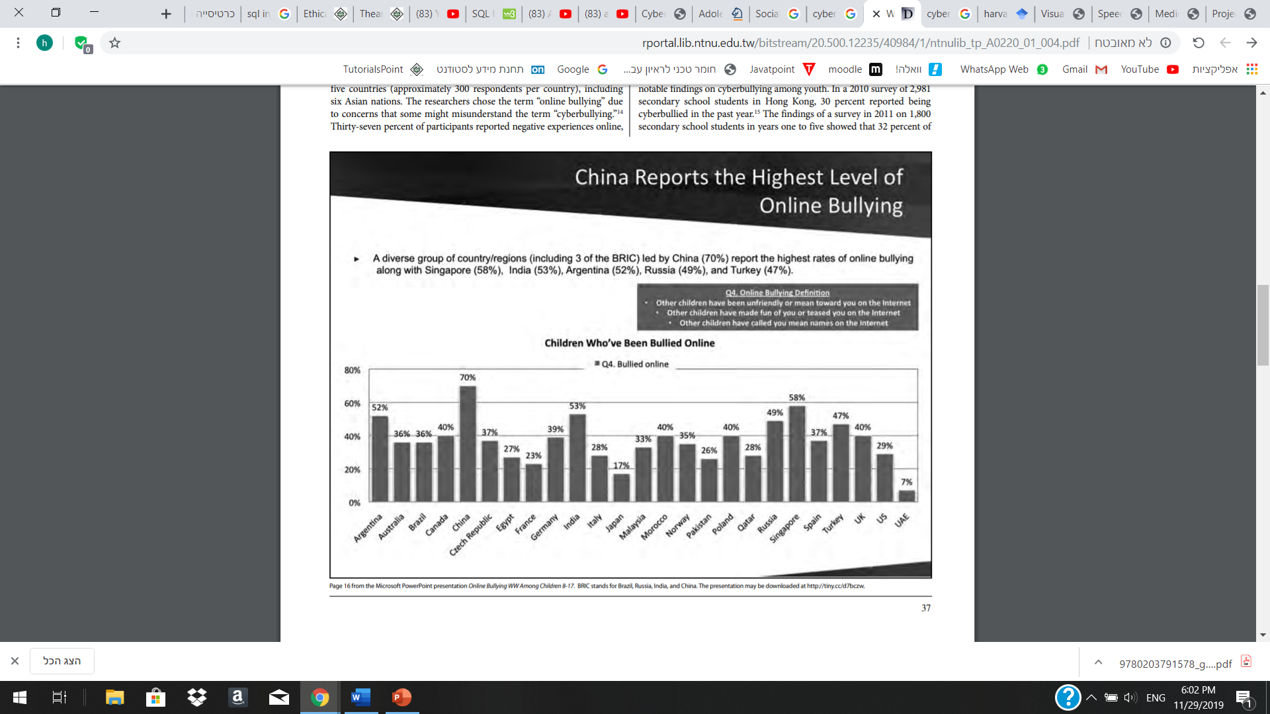Stealing a person’s account

Figure 1: Children around the world who have been bullied online, including: China- 70%, Argentina- 52%, Russia- 49%, from the “Cyber Asia and the New Media” paper, by Christine Suniti Bhat, Shih-Hua Chang, and Moira A. Ragan.[3]

* + 1. *Lack of caring*

The continent decrease in caring for each other, or even our surroundings, is an issue we must deal with.

Caring may be referred in many forms, such as:

* Helping others
* Volunteering
* Saving the environment

Although volunteer work is essential for maintaining a stable and thriving society,

we face a decreasing number of people who are willing to contribute, for others and for the environment we live in. For example, the volunteering rate of 2018 in the United States was 24.9%, compared to 28.8% in 2003-2005 (Figure 2).

According to Amy Yotopoulos, from the Stanford Center On Longevity, three reasons people do not volunteer are [4]:

* They do not have much time
* Lack of information and loss of interest
* No one has asked them to

Although we probably cannot influence their time management, we are able to inform them about diverse volunteer opportunities and share all the information they need about the work they are interested in.

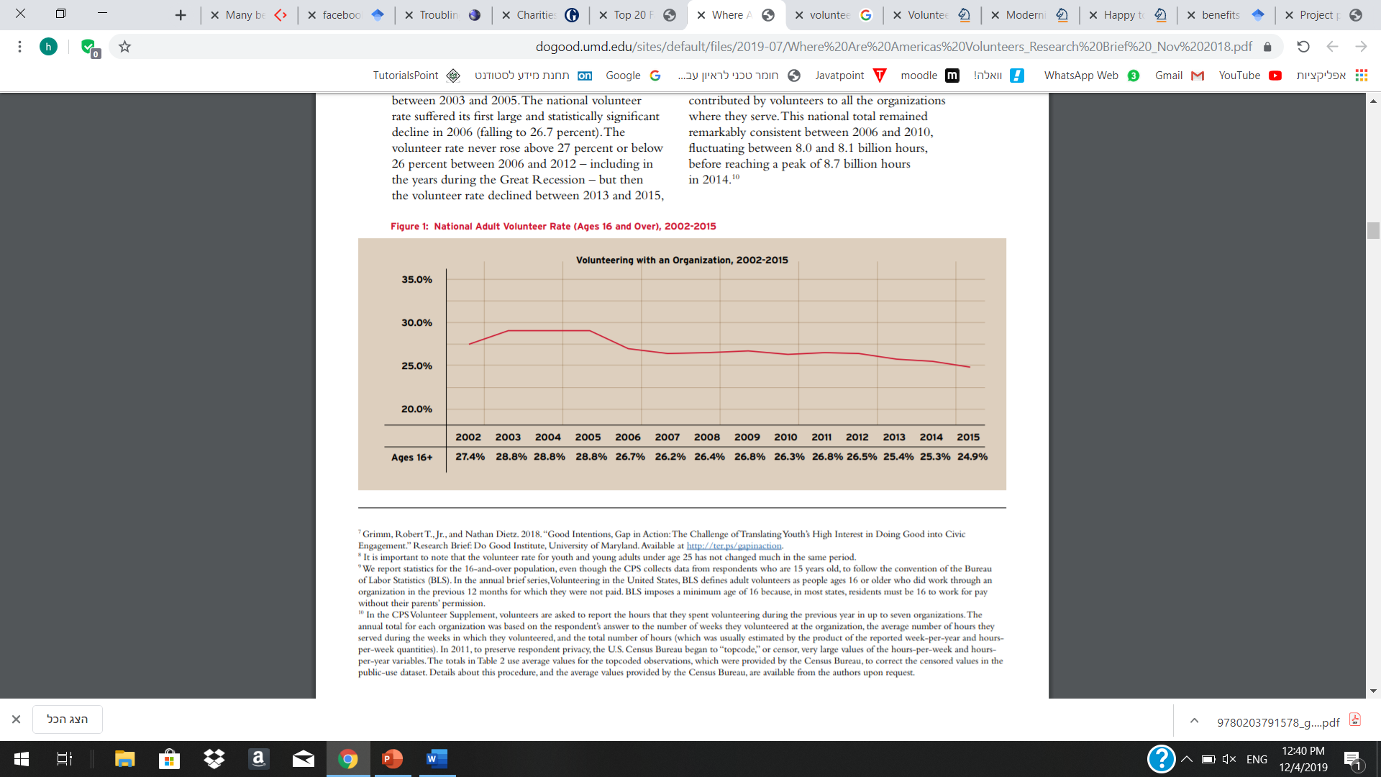

Figure 2: National adult volunteer rate in the United States (Ages 16 and Over), 2002-2015, from the University of MARYLAND, October 2018 [5]

* 1. **Market Research**

Currently, there are some famous organizations or applications that may suggest partial solutions for the problems which were discussed above. Let us discuss about those existing solutions and about the reasons we found them to be not completely satisfying:

* + 1. *Heroes for life*

Background: Heroes for life (i.e. lokhamim le'lo gvulot in Hebrew) was founded in 2013 by three IDF officers who served together in an elite unit. Their vision is to turn Israel into a global superpower of charity in developing countries and to run humanitarian volunteer projects in four different continents of the world. For this purpose, the organization sends delegations of volunteers combined of post- army Israeli travelers to contribute in poor countries, while supplying them food and accommodation during their volunteering time.

Usually the volunteering will be in an orphanage, and will include many different subjects, the main ones being- teaching English, calculus, personal hygiene, values, music and arts, renovating, painting and more.

For the present, 4100 children were assisted, in 4 continents, during 3 years of activity.[6]

Advantages:

* A truly decent opportunity for people who want to volunteer, while travelling the world.
* The organization and its published activities raise the awareness of poor people's problems and somehow manage to achieve caring.
* People who participate the program can meet with other people in the program and make new friendships.
* Volunteers get accommodation and food supply by the organization, while staying abroad.

Disadvantages:

* The volunteering is limited for post-army Israelis and only for certain activities, mainly in poor countries.
* There is no real time help for people who need it on the daily basis.
* The benefit that the volunteers get is limited.
* There is a potential to improve the connection between the volunteers and to make it become a larger, more connected community.
  + 1. *Facebook*

Background: Facebook is one of the most common social medias in the world, with approximately 1.62 billion daily active users (i.e. users who log in every day) as of September 2019. It has begun in February of 2004, as a school-based social network, by Mark Zuckerberg along with Edward Saverin.[7]

Their mission was to give people the power to build community and bring the world closer together. People use Facebook to stay connected with friends and family, to discover what is going on in the world, and to share and express what matters to them.

Advantages:

* Easy way to make new connections, as you can see people's interests and shared media.
* Publishing may help for business groups
* You can publish your thoughts, help others or ask for help.

Disadvantages:

* Does not encourage enough volunteer work.
* Might have offensive and harmful contents, especially comments and discussions.
* Does not encourage its users to participate in social meetings outdoors.
  + 1. *We Heart It*

Background:We Heart It was founded in 2007 by Fabio Giolito, a native of [Brazil](https://en.wikipedia.org/wiki/Brazil). He started the site as a side project around the idea of "hearting" photos and saving them for sharing with friends. In December 2013, We Heart It reached 25 million monthly users. We Heart It is an image-based [social](https://en.wikipedia.org/wiki/Social_media) network. It describes itself as "A home for your inspiration" and a place to "Organize and share the things you love." Users can collect (or "heart") their favorite images to share with friends and organize into collections. [8]

We Heart It is known for its positive community, since there are no features for commenting, users feel more comfortable posting content since it will not receive negative comments as it might on other social networks.

Advantages:

* Users can share and receive photos according to their topics of interest and communicate with other people in same circles of interest.
* Since there are no features for commenting, the topics stay pure and clean of bad discussions or harming comments, therefore the social network stays more positive.
* Users can find inspiration in the tips and photos that people post and get helped by that.

Disadvantages:

* The application does not encourage volunteering and helping each other enough.
* Users do not get the chance to participate in social events.
  1. **Our Insights**

Nowadays, cyber bullying and harassment are big issues, caring and volunteering rates are decreasing.

There are partially existing solutions for those problems including organizations as Heroes for life and applications as Facebook, We Heart It (and more), but there is no application that takes care of solving all of those on one platform.

* 1. **Our Solution**

2.4.1.*General description of the application*

Our approach is to solve the problems which we mentioned above with a social network application, called “BeSocial”. The application, that will be accessed internationally by anyone who uses android mobile phone and connected to the internet. To assure it works, we are using Google's Firebase backend as a service (some more details on the next section). The application will include features which will support making new connections and sharing information with each other (e.g. posts, picture uploads, messages etc.). In addition, it will also include features which will allow the users to volunteer, get help, see upcoming social or volunteering events. The application will encourage the users to help others and participate in social events by giving them special benefits- as more they are active, the more they get.

* + 1. *Firebase as a backend service*

[9] Firebase is Google's mobile platform that helps you quickly develop high-quality apps and grow your business. Firebase provides several services which help us to build our application faster, more secure and efficient. Some of its services are:

* User authentication: Firebase Authentication aims to make building secure authentication systems easy, while improving the sign-in and onboarding experience for end users. It provides an end-to-end identity solution, supporting email and password accounts, phone auth, and Google, Twitter, Facebook, and GitHub login, and more.
* [Cloud](https://firebase.google.com/products/crashlytics/) functions: Cloud Functions for Firebase is a serverless framework that lets you automatically run backend code in response to events triggered by Firebase features and HTTPS requests.
* Real-time database: The Firebase Realtime Database is a cloud-hosted NoSQL database that lets you store and sync data between your users in real-time.
* Cloud storage: Cloud Storage is designed to help you quickly and easily store and serve user-generated content, such as photos and videos.
  + 1. *Android platform as a frontend*

Our application is suitable for Android operation systems and designed mostly for standard mobile phones. In our implementation we take advantage of those Android mobile phone's services:

* Background location services: When the permission is given and the action is activated, the application receives its user's location in the background. We use it to determine the user's location for maps activity and for check-in to events (it will be described more in section 2.4.13).
* Broadcast receiver: Broadcast receiver receives location updates from the background location service and determines if the user is currently in an event location. We also use a broadcast receiver to receive connectivity updates and inform users whether they need to connect to the internet.
* Local storage: The application uses the device's local storage to save the user's username and password for easy log-in method after the user logged out.
  + 1. *Our application: better social experience*

As in most social networks, our users will be able to upload and share pictures and thoughts, view profiles and chat with other users. Furthermore, they could be a part of social events according to their interests, getting to know other users with similar interests as theirs. While this being said, "BeSocial" will act to keep the vibes of the social network more positive, by allowing user only to like posts, no comments. We will act as much as possible for not allowing abusive content or abusive users, by removing bad posts and blocking this kind of users. Users will be able to report other users or offensive content, all for making the user's social experience cleaner and more positive.

* + 1. *Content filter algorithm*

As part of the user social experience, our application will combine a special algorithm for filtering abusive text content. The algorithm:

1. First, load the list of abusive words (CSV file) to a hash map(key-value), and save the length of the longest word.
2. When a user writes a text content and presses 'send':
   1. From the beginning of the content, move on each letter and check if there is a consecutive set of letters that is included in the abusive words hash map.
   2. If there are abusive words, add them to an array of bad words.
3. Check if the array of the abusive words is empty, if yes-let the user post the content, if not, pop a text dialog to let the user know there are bad words in his input and do not enable the text to be uploaded.

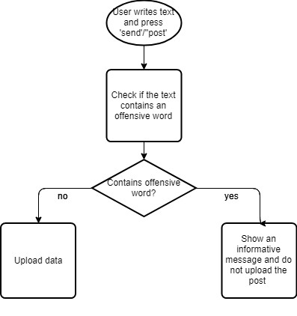

Figure 3 - Textual content filter algorithm

* + 1. *More friendship making, volunteering and social meetings*

Our goal in "BeSocial" is to create a real supportive and friendly community. Therefore, the application will provide a convenient platform to communicate with other users by using chat, to volunteer and get help from others by creating a "get help" events or searching for other users' events around. Users will also be able to socialize and meet new people outside of the social network by attending fun social events, organized by event organizers of the company. In order to boost users to participate in the activities of the application, we will use the "social points" and bonuses method. Bonuses will come in form of benefits in selected companies on different categories (e.g. discounts in clothing stores, coffeeshops, movie theaters, sports and etc.). Moreover, selected high ranked users would be able to participate in high-valued events of "BeSocial", such as barbeque events, bar tours, community service volunteer events and even volunteering abroad, all for free or sometimes even getting paid while filling the role of event organizers. As part of the benefits method, users who make "positive" actions such as: connecting with other users by sending a message, helping others, participating in social or volunteering events and etc., will be benefitted by receiving "social points". These points are required for level-ups of users' ranks and receiving bonuses, the higher the rank is- the better the available benefits are.

* + 1. *Ranks and points*

As explained before, the method of benefits to the users is an important key for our application to boost users helping each other, volunteer and meet. The following paragraphs explain more about this method. Users can view their "social points", ranks and benefits in the "bonus area". Here is the list, in escalating order, of the ranks and the defined "social points" which user should accumulate to receive them:

1. "Shy socializer": 0-199 points.

2. "Out of the shell socializer": 200-799 points.

3. "Academic socializer": 800-2599 points

4. "Socialized ninja turtle": 2600-5999 points.

5. "Socialosaurus": 6000 points and on.

* + 1. *Ways to receive "social points"*

Users would be able to gain "social points" by being active in different ways as the following:

* Start a new conversation with other user- 2 points.
* Accept a new conversation – 1 point (the sender receives the 2 points)
* Help people on volunteering events- 50 points.
* Contribute in management volunteering event-100 points.
* Participate in a management social event-50 points.
  + 1. *Redeem benefits*

Once a user has gained sufficient amount of social points, they will be able to redeem benefits from the store.

Each rank comes with its unique bonuses and limitations on claiming them. The user enters the “Bonus Area”, chooses the specific benefit he wants and asks to claim it.

After he chooses, he gets a serial code for the benefit, which he can go to the specific business and use his benefit.

* + 1. *Home page and posts*

The home page in our application will mainly show posts of users. The default case will be showing the posts of all the users, since we believe this is a good way for users to communicate with other users who they do not know yet and make new friends.

* + 1. *Creating events, asking for help and volunteer*

For assuring that users will have a proper platform for receiving help, meet new people- not only virtually, and volunteer in some special occasions, we use the events form.

Users can create a new public event as a "help me" event for asking for help or "social event" for meeting people. Users will be able to use filters as choosing category, choose geographical area, see their own created events. Of course, users can participate in public events by pressing 'attend' button.

Participating in social events and helping others not just will spiritually and physically benefits users, but also add some "social points" to their accounts which will be translated into material benefits and higher rank in the bonus area.

* + 1. *Checking in to events and receiving the points*

During the dates of the occurrence of the events, users who pressed the "attend" button on those events area would be able to check-in and receive the suitable amount of points according to the event's type. There are two methods to check in:

1. Check-in by user's location: our application uses location-based algorithm, it filters the events which the user marked them as "attending", and it checks if the events are currently occurring by their dates. If the events are occurring, it set a Geofence of 100 meters around their location. The Geofencing mechanism works in a way that if a device enters or dwells in the geofence defined area (the device's location is constantly being taken by a background service and broadcasted to a broadcast receiver of the application), it recognizes the event. On that point, our code is activated to check-in the user.
2. Check-in manually by the event's creator: users can ask the event's creator to search their name in the attendants list of the event. Once they find them on the list, the creator can press the "give credits" button- and the user is checked-in.
   * 1. *Starting a new conversation and receiving points*

Users are encouraged to open a new chat conversation with other users by receiving social points.

The process is simple: a user sends a new message to another user. The user on the other side decline or approves the message. If approved, the receiver gets 1 point and the sender gets 2 points. if declined the conversation is deleted.

* + 1. *Cloud functions and points*

When users check-in to events or approve a new conversation, they trigger a cloud function that sits on the Firebase's server. Once the user triggers the function by database event trigger or HTTPS request, the function receives necessary details about the event such as user's id, event name and type of event.

The function, which is written in JavaScript and deployed by Node.js to the Firebase's server, checks which is the suitable amount of points to give to the user, upgrade their rank if needed and send a notification to let the user know about that news.

1. **SOFTWARE ENGINEERING DOCUMENTS**
   1. **Requirements**
      1. 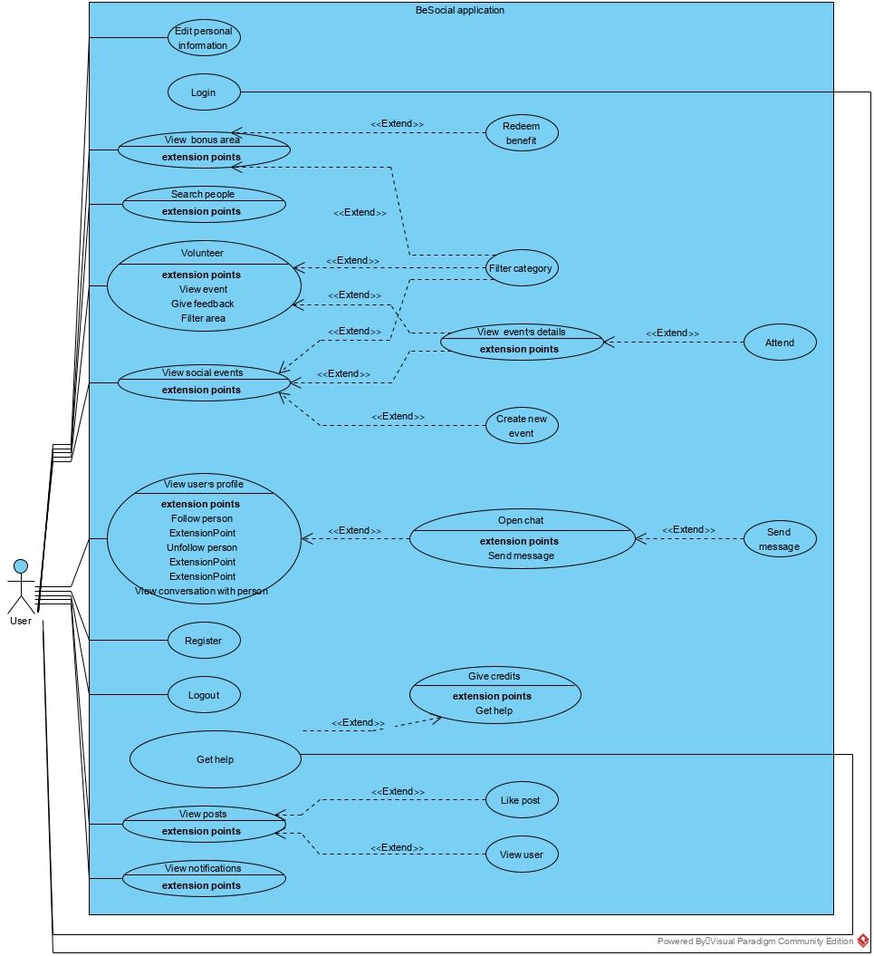U*se-case*

Figure 4 - Use case diagram

* + 1. *Requirements table*

Main requirements of our application, graded with priority of 1-5, where 5 is the highest priority and 1 is the lowest:

|  |  |  |
| --- | --- | --- |
| **Users** | | |
| **Priority** | **Description** | **Requirement** |
| 5 | User can post social events by categories and ask for help event. | Create event |
| 5 | Users can attend to event. | Attend to event |
| 3 | Users can cancel their attendance to an event. | Cancel Event attending |
| 5 | User receives points for starting a new conversation (2 points) or approving one when another user opens (1 point). | Receive points for new conversation |
| 5 | User receives 50 points for checking in to management social event, or 100 points for volunteering management event. | Receive points for management event check-in |
| 5 | User receives 50 points for checking-in and helping other users in volunteering event. | Receive points for volunteer event check-in |
| 5 | User can accumulate bonus points by volunteering, checking-in to company's events and sending a new first message to a user. User can reach higher ranks. | Bonuses and rank mechanism |
| 5 | User can redeem points in "social store" to receive benefits. | Redeem points in social store |
| 5 | Users can check-in to the events during the time they occurred by location. | User location check-in |
| 5 | Users can check-in to the events during the time they occurred by manual action of the event creator. | User manual check-in |
| 4 | Users can open a chat conversation with other users. | Chat |
| 2 | Users receive notification about 'likes' on their posts. | Check-in to event notifications |
| 2 | Users receive notification about checking-in to events. | New conversation notifications |
| 2 | Users receive notification about rank upgrades. | Rank upgrade notifications |
| 5 | Users can press on destinations in the drawer menu and navigate. | Menu navigation |
|  | Users can navigate to the "About" page to view details about the application. | View details about the application |
| 3 | A user can choose his public profile picture. | Profile picture choosing |
| 1 | A user can edit his own user details and choose a profile picture. | Profile details editing |
| 3 | Users can share their thoughts in public. | Posts |
| 3 | Users can like other posts. | Like |
| 3 | Users can search other users. | Search |
| 5 | People can open an account. | Sign-up |
| 5 | Users can log-in to their account. | Log-in |
| 5 | Users can log-out of their account. | Log-out |

|  |  |  |
| --- | --- | --- |
| **Managers** | | |
| **Requirement** | **Description** | **Priority** |
| Block users | Manager can block users. | 3 |
| Retrieve users | Manager can make users active again. | 3 |
| Add benefit to the social store | Managers can add a benefit to the social store. | 5 |

* 1. **Design**
     1. *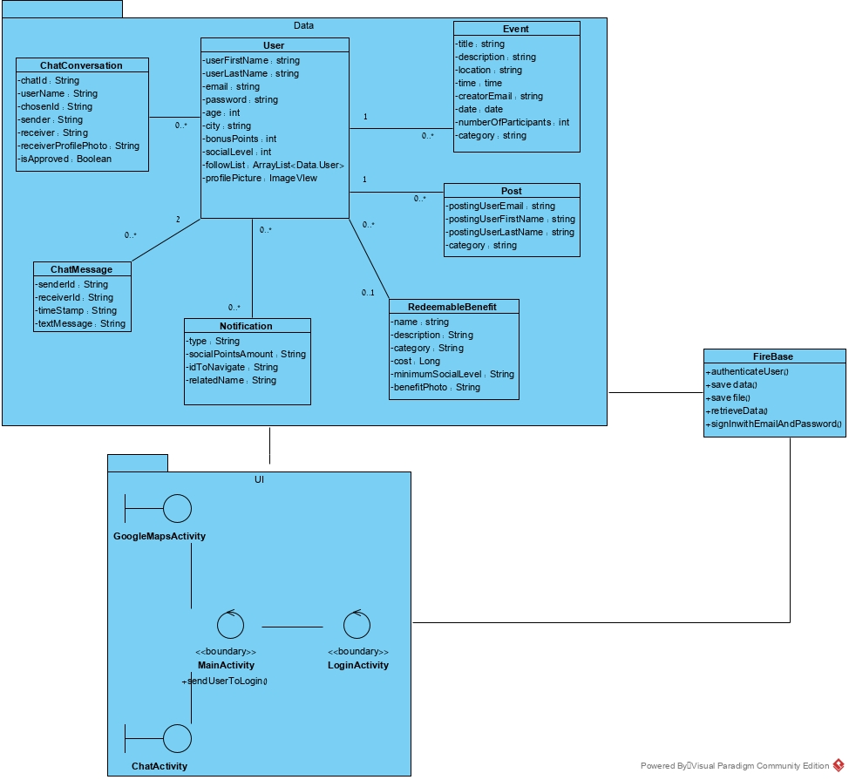Class diagram*

Figure 6 - Class diagram

* + 1. *Starting a chat conversation activity diagram*

The following diagram demonstrates the way users can start a chat conversation and receive points:

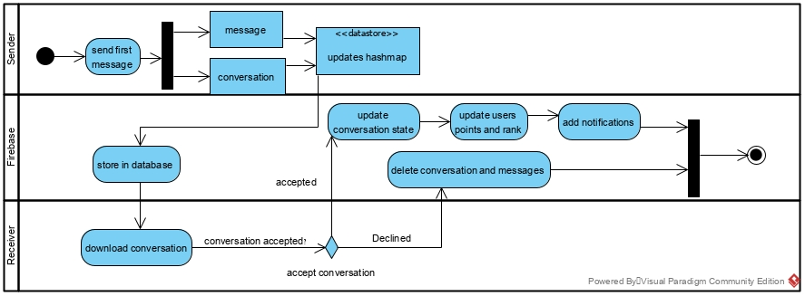

Figure 7 - Starting a chat conversation: the sender sends a message; the receiver receives it and decide if to accept or decline.

* + 1. *Asking for help and volunteer: location-based check in activity diagram*

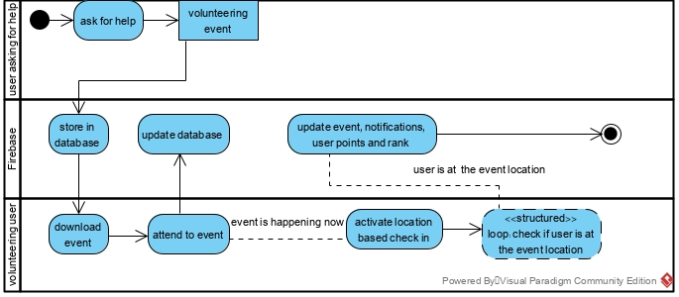

Figure 8 - Asking for help and volunteering: user asks for help; another user who attends to the event checks in to the event based on his location.

* + 1. *Asking for help and volunteer: manually check-in activity diagram*

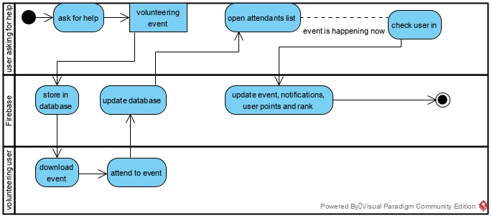

Figure 9 - Asking for help and volunteering: user asks for help; another user who attends, can check in to the event manually by the event's creator.

* + 1. *Graphical User Interface (GUI)*

In this section, we will introduce the first design of the User Interface (UI).

As part of a good and informative UI, we tried to create an informative environment, simple and convenient to handle. It is essential to give the best experience while using the application.

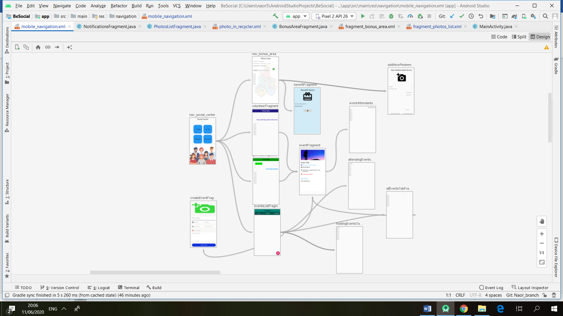

Figure 10 - Social Center: users can visit the social store for redeeming points for benefits, users can create events, view other events and attend, ask for help and volunteer.

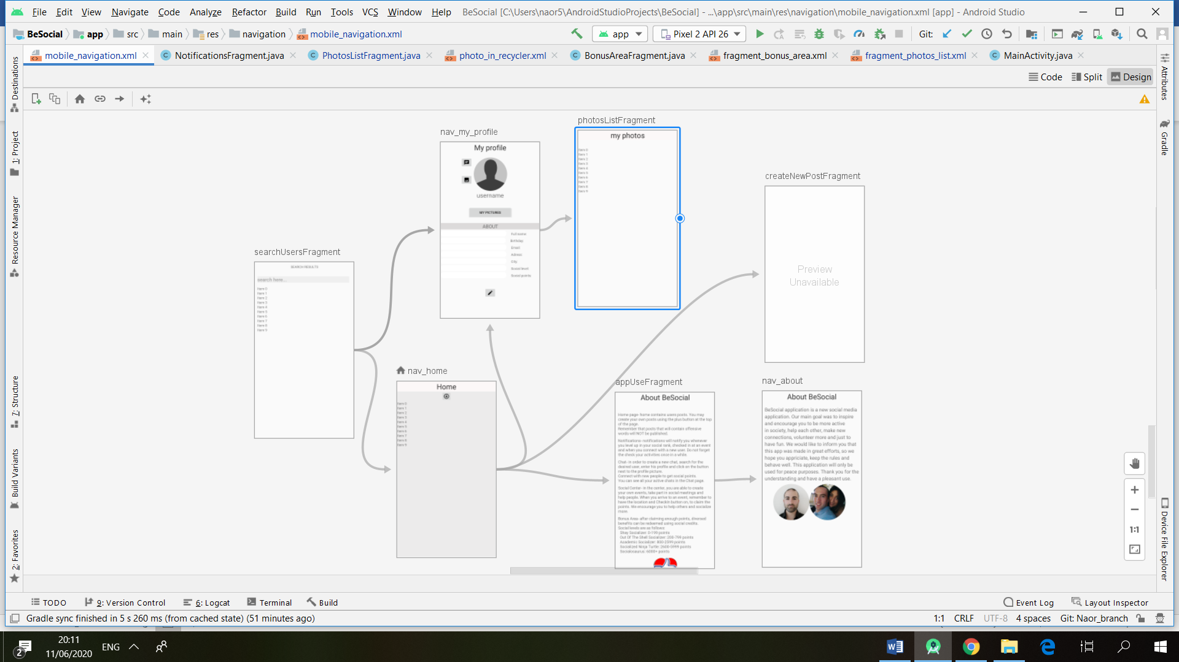

Figure 11 – Home: users can view posts and publish their thoughts with pictures, navigate to their profiles and profile of other users, edit their details and profile picture, search users and read the details about the application.

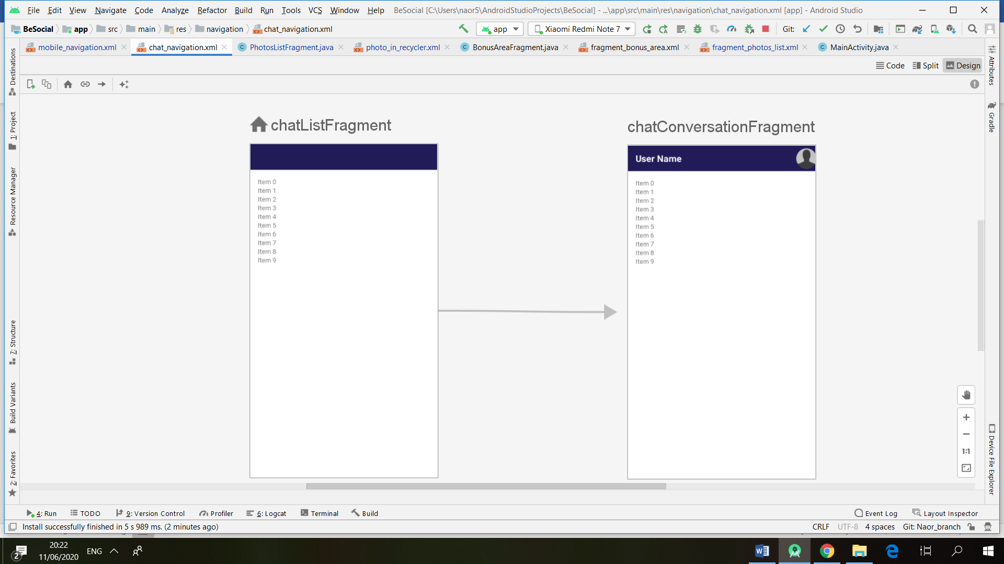

Figure 12 – Chat: users can choose a conversation from the chats list and navigate to the conversation to read and write new messages.

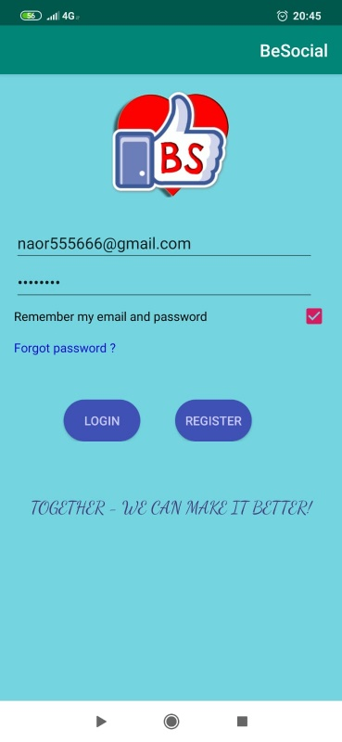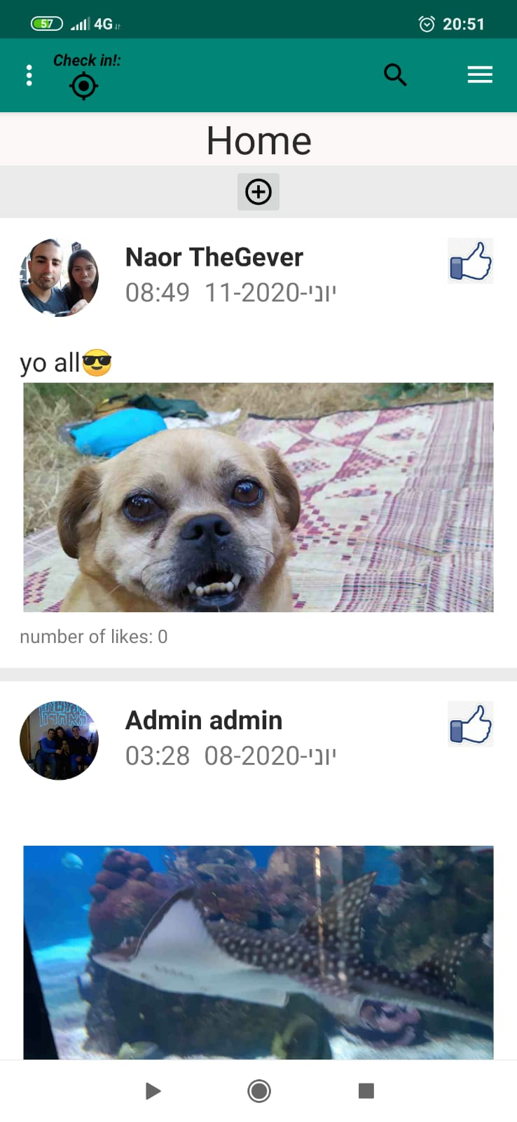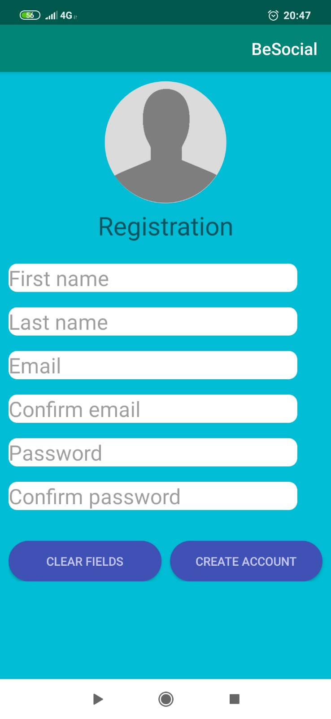

Figure 13 - Login page

Figure 10 - Home page

Figure 9 - Registration

* 1. **Testing**

We will perform a series of testing cases, covering a variety of common scenarios of using the application.

The testing plans will ensure the reliability of our system and will prevent uncomfortable situations.

* + 1. *Registration and login testing*

|  |  |  |  |  |
| --- | --- | --- | --- | --- |
| Test name | Description | Expected results | Actual results | Comments/requirement name |
| False  registration | Choose “Register” option, enter not valid details and press “Register”. | We get a toast, saying the details we entered are not valid. | V | Sign-up |
| Complete registration | Choose “Register” option, enter appropriate details and press “Register”. | A feedback is given, a new user is registered in the DB and we are back to login page | V | Sign-up |
| False  user login | Try to perform a login with an unregistered user. | We get a toast, saying the username or password are wrong. | V | Log-in |
| Successful user login | Enter registered username and password and press “login”. | The user’s home page is shown on the screen. | V | Log-in |

* + 1. *User actions testing*

|  |  |  |  |  |
| --- | --- | --- | --- | --- |
| Open “My profile” page using menu | Press “My Profile” on menu. | Profile fragment is shown on screen | V | Menu navigation |
| Open “Chat” fragment using menu | Press “Chat” on menu. | Chat fragment is shown on screen | V | Menu navigation |
| Open “Social Center” fragment using menu | Press “Social Center” on menu. | Social center fragment is shown on screen | V | Menu navigation |
| Open “Bonus Area” fragment using menu | Press “Bonus Area on menu. | Bonus area fragment is shown on screen | V | Menu navigation |
| Enter a user’s profile | On home, choose a post, press its user’s profile picture. | The user’s profile page is shown on screen. | V | Menu navigation |
| Post ask for help event | Post a new help event. | The new event is shown in the category’s help event list. | V | Create event |
| Attend to event | Press “Attend” on event’s page. | On the event page, the user appears in the attending list after pressing 'View attendants' | V | Attend to event |
| Cancel attending | Press “Cancel attending” on event’s page | On the event page, the user does not appear in the attending list after pressing 'View attendants' | V | Cancel event attending |
| Search a person | Press on the search icon on the application bar and write a name of an existing user | The user appears in the searched list. | V | Search |
| Like a post | Press on the "like" icon on the upper corner of a post. | The "like" icon changes to green and the number of likes is increased. | V | Like |
| About | Press the about item on the main menu at the application's bar | The about page is opened | V | View details about the application |
| Change profile picture | Near the profile picture at the user's profile page, click on the "upload picture" icon and choose a photo | A photo will appear and will continue appearing after re-entering the application. | V | Profile picture choosing |
| Location-based check-in to events | At the event location, if the user is attending to the event and the event occurs, press on the "check-in" icon. | A notification is shown for checking in and points are received. | V | User location check-in |
| Manual check in to events | At the event page, if the user is attending to the event and the event occurs, the event creator presses on the "check-in" icon. | A notification is shown for checking in and points are received. | V | User manual check-in |
| Send a chat message | Navigate to other user's profile, open click on the chat icon and send a message. | The other user can see the conversation. | V | Chat |
| Manual check-in | Give feedback on the user that helped you, fill details and press “send” | The event is closed, a feedback and bonus points are sent to the helper. | V | User manual check-in |
| Bonus level up | Get enough points to level up in bonus area. | The user is informed they have reached a new bonus level. | V | Bonuses and rank mechanism |
| Redeem benefits | Choose a benefit from the bonus store, press “Redeem” | The user is informed that he redeemed the benefit. The amount of points redeemed. | V | Redeem points in social store |
| False logout | Press “Logout” on menu, then press “No” in the dialog. | The user stays logged in, the last page is shown on screen. | V | Log-out |
| Successful logout | Press “Logout” on menu, then press “Yes” in the dialog. | The user is no longer logged in, login page is shown on screen. | V | Log-out |
| Blocked user | Perform login to a blocked user. | An error message occurs, and the user is not logged in. | V | Block user |

* + 1. *Manager actions testing*

|  |  |  |  |  |
| --- | --- | --- | --- | --- |
| Block user | Enter user’s profile, press “Block user” button. | The user is blocked and cannot login anymore, they receive a message. | V | Block user |
| Re-activate users | Enter user’s profile, press “Retrieve user” | The user is active again an able to login. | V | Retrieve user |
| New benefit | Enter new benefit details in “Bonus Area” | A new benefit is shown in the benefits list. | V | Add benefit to the social store |

1. **RESULTS AND CONCLUSIONS**

In the recent years volunteering, helping others and new friendships making is on decrease and it is a problem. It is possible to encourage people to reverse this trend by many different way, a convenient one way is by technology platform. We suggest a solution for the problem in a form of a social network for Android mobile devices. With our solution, it is fun and easy to reach other people, volunteer, ask for help, attend to social meetings and meet new friends. One of our application's advantage comparing to other solutions is our clean way of presenting a social network. No comments mechanism, text content filter algorithm and general positive atmosphere make it light, user friendly and appealing. The main strength of our solution is the bonuses section. Positive actions e.g. volunteering, meeting others, helping the society and starting new conversations will reward our users with points to redeem for discounts in businesses and other benefits. On the other side, our application suffers from lack of improved design elements since we were focused on producing a prototype that will satisfy firstly most of our functional requirements. In addition, time and space efficiency improvements and more functionalities can be obtained in the future with the help of creativity, advices of other users and hardware support

**References:**

[1] <https://wearesocial.com/blog/2019/01/digital-2019-global-internet-use-accelerates> - introduction , user numbers

[2] <https://gs.statcounter.com/os-market-share/mobile/worldwide> - Android users percentage

[3] <http://www.bullyingstatistics.org/content/cyber-bullying-statistics.html> - Cyber bullying statistics

[4] <http://longevity.stanford.edu/three-reasons-why-people-dont-volunteer-and-what-can-be-done-about-it/> - why people do not volunteer – Stanford center of longevity

[5] <http://rportal.lib.ntnu.edu.tw/bitstream/20.500.12235/40984/1/ntnulib_tp_A0220_01_004.pdf> - Cyber bullying paper(Figure 1 )

[6] heroes for life - (source) <http://hfl.org.il/en/#delegations>

[7] Facebook- <https://about.fb.com/company-info/>

[8] **we heart it -** <https://impactsocialmedia.net/what-is-weheartit-weheartit-review/>

[9] Firebase - <https://firebase.google.com/>